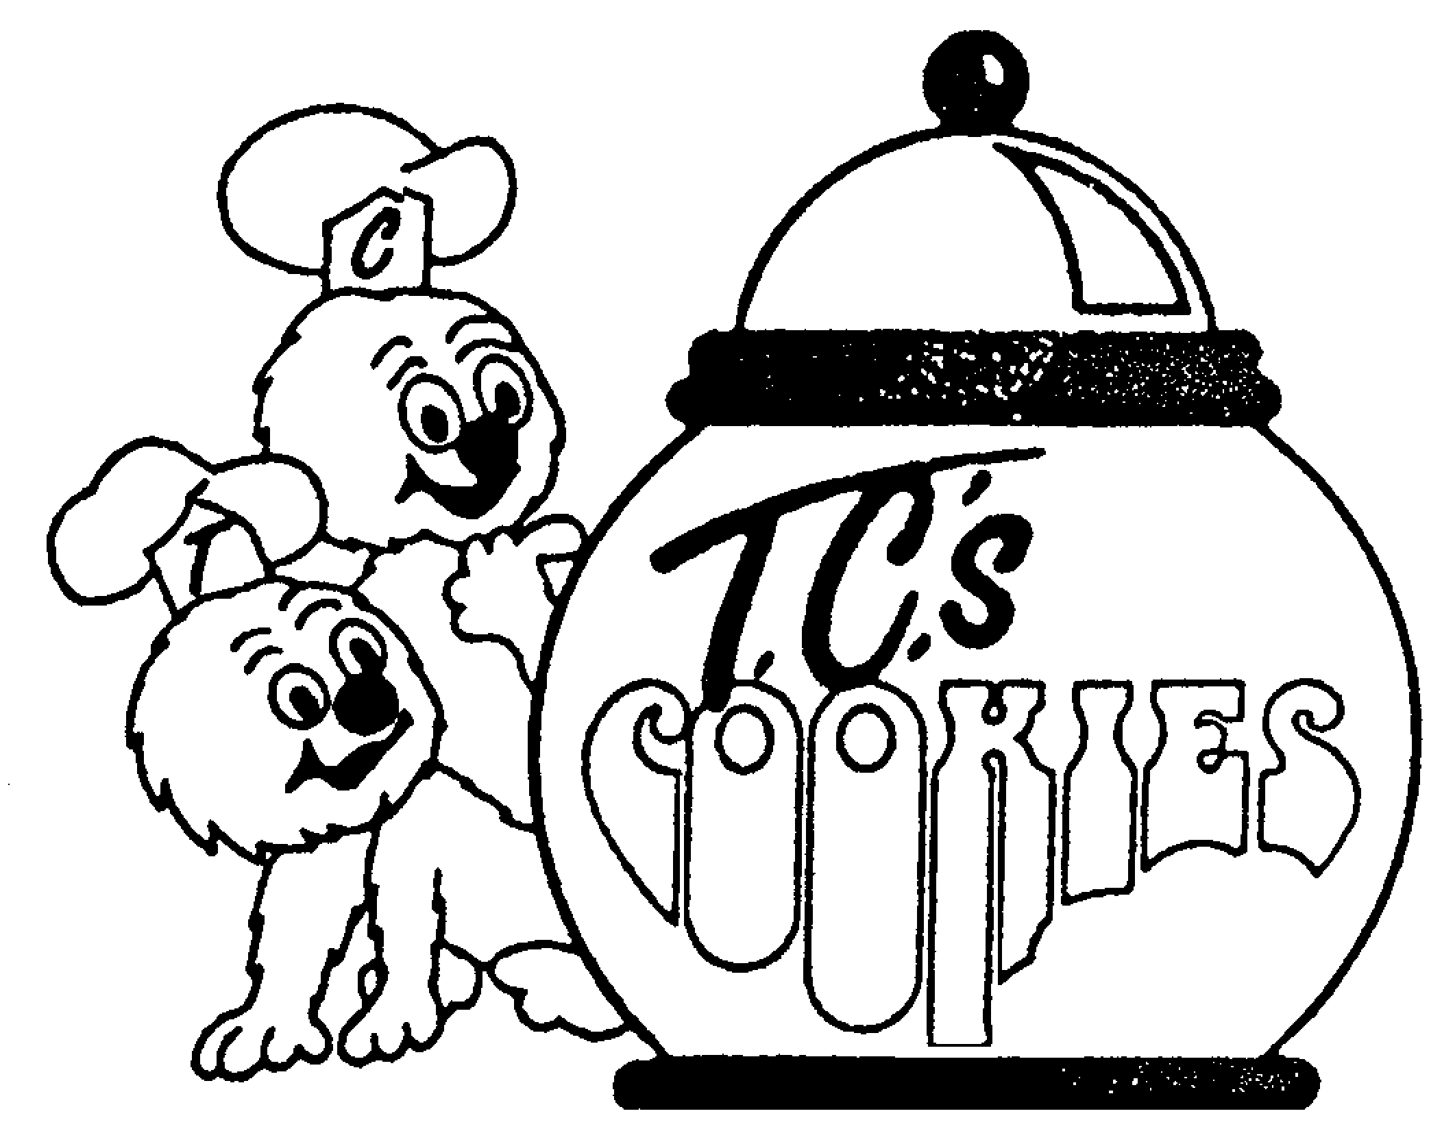

T.C.'s Menu – Sept 2010

Baked Cookies – delivered Frozen

Code Product Size Pack Price Each

(<3.6 g of fat + 2g of fibre )

Compliant with
Ministry of Education Policy 150

Sell
Most
Category

1002-D Chocolate Chip DeLite Small, Bulk 96/case $28.25 .29
3002-D Oatmeal Raisin Small, Bulk 96/case $28.25 .29
4002-D Fudge Chip DeLite Small, Bulk 96/case $28.25 .29
5002-D Oatmeal Choc Chip DeLite Small, Bulk 96/case $28.25 .29
6002-D Oatmeal DeLite Small, Bulk 96/case $28.25 .29

(5 g of fat + 3g of fibre)
1003-D Chocolate Chip DeLite Large, Wrapped 48/case $26.25* .55*
3003-D Oatmeal Raisin DeLite Large, Wrapped 48/case $26.25* .55*
4003-D Fudge Chip DeLite Large, Wrapped 48/case $26.25* .55*
5003-D Oatmeal Choc Chip DeLite Large, Wrapped 48/case $26.25* .55*
6003-D Oatmeal DeLite Large, Wrapped 48/case $26.25* .55*

1004-D Chocolate Chip DeLite Large, Bulk 48/case $23.25 .48
3004-D Oatmeal Raisin DeLite Large, Bulk 48/case $23.25 .48
4004-D Fudge Chip DeLite Large, Bulk 48/case $23.25 .48
5004-D Oatmeal Choc Chip DeLite Large, Bulk 48/case $23.25 .48
6004-D Oatmeal DeLite Large, Bulk 48/case $23.25 .48

T.C.’s Original Recipes

T-1001 Chocolate Chip Tiny, Bulk 288/case $27.75 .10
T-4101 White Chocolate Fudge Tiny, Bulk 288/case $27.75 .10
T-10001 White Chocolate Tiny, Bulk 288/case $27.75 .10

1003 Chocolate Chip Large, Wrapped 48/case $26.25* .55*
1103 Casey’s-Caramel & Choc Large, Wrapped 48/case $26.25* .55*
4103 White Chunk Fudge Large, Wrapped 48/case $26.25* .55*

1004 Chocolate Chip Large, Bulk 48/case $23.25 .48
1104 Casey’s- Caramel & Choc Large, Bulk 48/case $23.25 .48
4104 White Chunk Fudge Large, Bulk 48/case $23.25 .48

DAWG Collection! – Rice Krispie Bars
Dawg-D DuneDawg Large, Wrapped 48/case $28.25* .59*
Dawg-M MudDawg (with chocolate) Large, Wrapped 48/case $28.25* .59*

Specialty COOKIES (available special months only)

8003-P Vanilla Pumpkin (Oct) Large, Wrapped 48/case $27.25* .57*
8003-S Vanilla Snowman (Nov/Dec/Jan) Large, Wrapped 48/case $27.25* .57*
9003-GT Ginger Teddy (Nov/Dec) Large, Wrapped 48/case $27.25* .57*
8003-H Vanilla Heart (Feb) Large, Wrapped 48/case $27.25* .57*
8003-B Vanilla Butterfly (Mar/Apr/May) Large, Wrapped 48/case $27.25* .57*

ICE CREAM SANDWICHES WITH DELUXE VANILLA ICE CREAM (Apr, May & June)

Ice Dawg I Chocolate Chip 70 gram, Wrapped 48/case
Ice Dawg IV Fudge Chip 70 gram, Wrapped 48/case

Gluten Free Items

GF-10 Chocolate Chip Cookies ½ lb bag 225 gram per item $5.00
GF-15 Brownies 7 ½ “ pan 325 gram per item $7.00
GF-24 Unbaked Pastry 250 gram per item $2.50
GF-26,27&28 Unbaked Apple, Blueberry & Cherry Pies 8” pan 700 gram per item $9.99

Other Gluten Free products available (breads, buns & cakes) from O’Dough’s & Goodbye Gluten.

100% Pure Unsweetened Juices
Sell Most
Category
OASIS Apple Juice 200 ml tetra 30/case $11.75 .39
OASIS Wildberry Juice 200 ml tetra 30/case $11.75 .39
OASIS Seven Fruit Tropical Juice 200 ml tetra 30/case $11.75 .39
. . . . . . . . . . . . . . . . . . . . . . . . . . . . . . . . . . . . . . . . . . . . . . . . . . . . . . . . . . . . . . . . . . . . . . . . . . . . . . . . . . . . . . . . . . . . . . .
www.terracottacookies.com “Pleased to be Peanut & Nut Free!” 905 877 4216

*plus HST

